### **Step 1:Create a Helper Cookbook**

# cd /home/ubuntu/chef-repo

# chef generate cookbook yum

**Step 2:Write recipe for package**

# vim/home/ec2-user/chef-repo/cookbooks/yum/recipes/default.rb

execute "yum update" do

command "yum update -y"

end

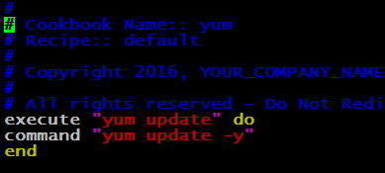

**Note :**A **execute** resource block typically executes a single command that is unique to the environment in which a recipe will run. Some **execute** resource commands are run by themselves, but often they are run in combination with other Chef resources. For example, a single command that is run by itself:

**Step 3:At the top of this cookbook, before the other resources that we have defined, we can read in the "apt" default recipe by typing**

# vim /home/ubuntu/chef-repo/cookbooks/httpd/recipes/default.rb

include_recipe "yum"

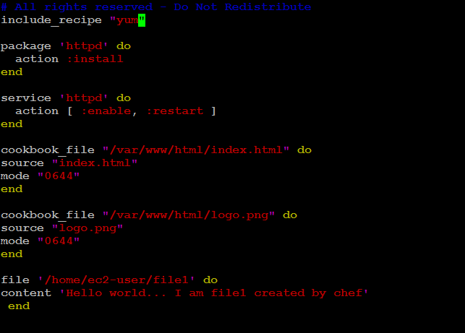

**Step 4 :Edit metadata.rb**

# vim /home/ec2-user/chef-repo/cookbooks/httpd/metadata.rb

depends "yum"

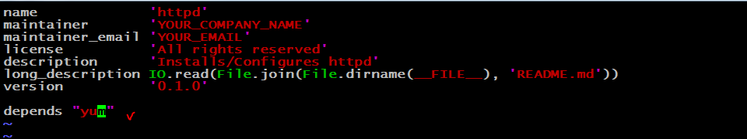

This file is checked when the Chef server sends the run-list to the node, to see which other recipes should be added to the run-list.

## **Step 5:Upload Cookbook to chef-server**

# knife cookbook upload yum

# knife cookbook upload httpd

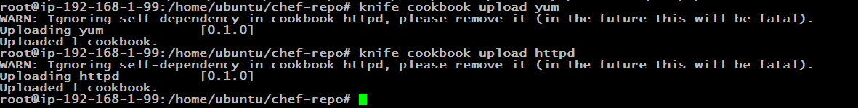

**Tips :ENusre : you are in /home/Ubuntu/chef-repo ( when your un upload commands)**

**Option validation of uploading cookbook**

# knife cookbook upload httpd

**Step 6:Alternatively to check from command line on what cookbooks are uploaded on cehf-server**

# knife cookbook list

After we install the service, we probably want to adjust its current state on the node.

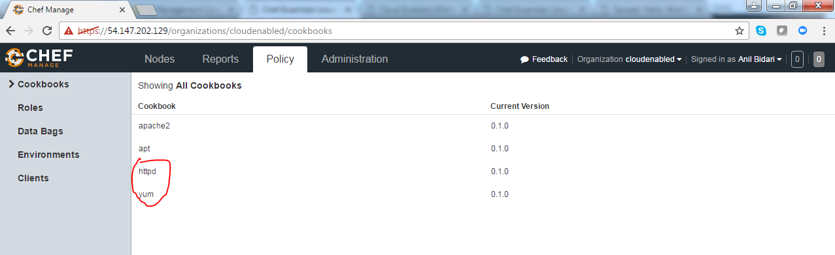

**Step 7:attach yum run list the rhel node**

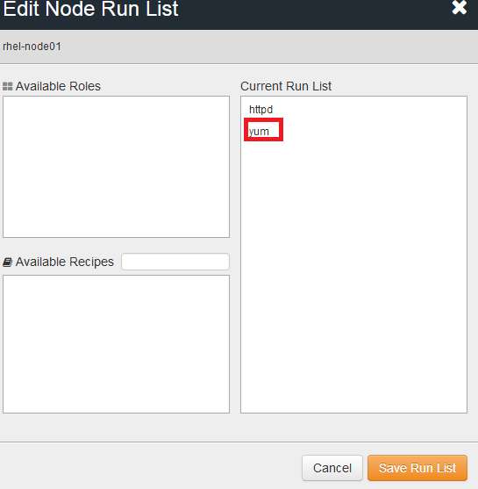

## **Step 8 :run chef client on rhel node**

knifessh "*:*" -x ec2-user --identity-file chef.pem "sudo chef-client"